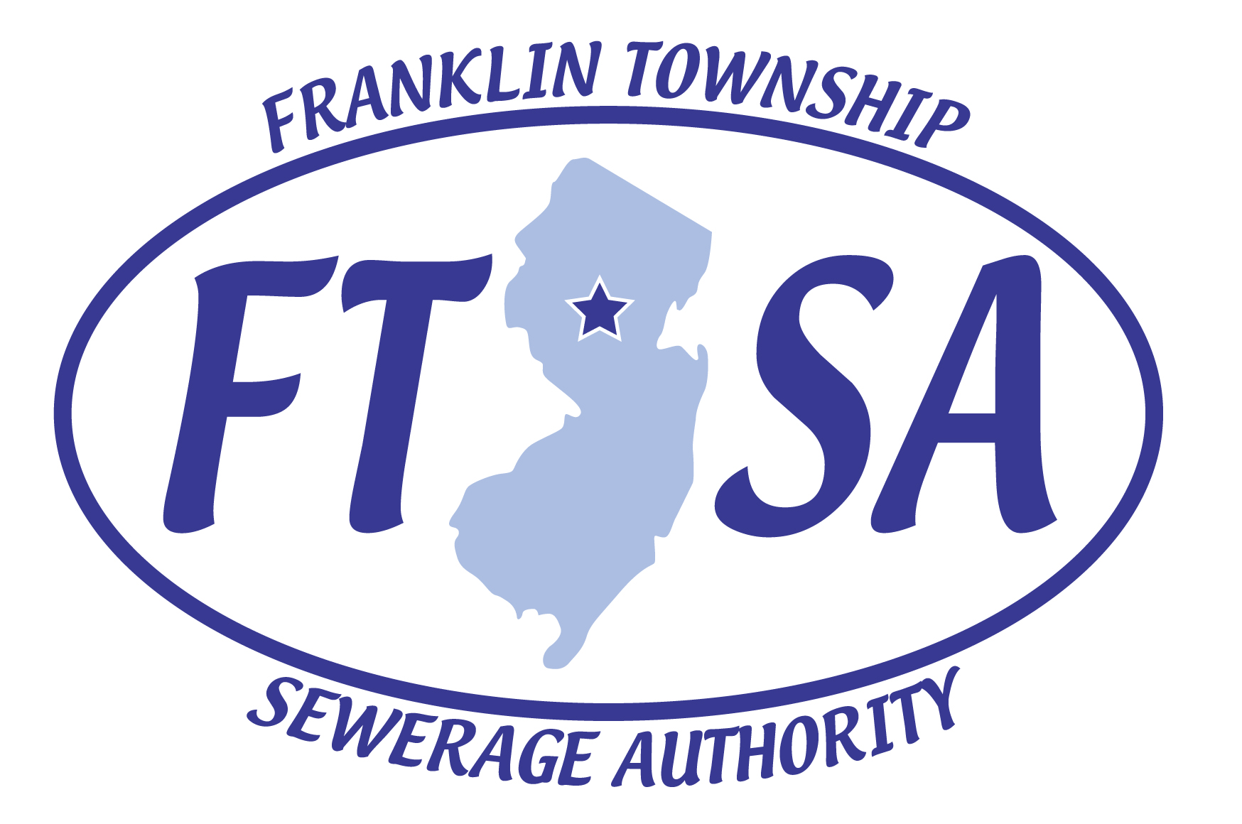

NOTICE TO ALL REDUCED SEWER RATE CLAIMANTS

To comply with the Franklin Township Sewerage Authority’s “Rates, Rules & Regulations” Reduced Sewer Rate for the year 2021, you must complete, sign, and return the enclosed form before December 15, 2020 to Franklin Township Sewerage Authority.

This application must be completed and submitted every year to receive the sewer rate reduction. If the application is not received, this reduction will not be approved and will be removed from your account.

If you have any questions, please contact the Franklin Township Sewerage Authority Office located at 70 Commerce Drive, Somerset, NJ 08873, or call our Billing office at (732) 873-2121.

Franklin Township Sewerage Authority

